Request for Proposals to host the USA Ultimate College Championships

Overview

USA Ultimate (USAU) is the National Governing Body for the sport of Ultimate in the United States. USAU is a member of the World Flying Disc Federation (WFDF) which serves as the international governing body for the sport of Ultimate. USAU was founded over 30 years ago, and the sport has recently been called the fastest growing team sport in the nation and the fastest growing field sport in the world. USAU has over 50,000 members and there are over 700 college and university teams that compete in our College Championships every year. The College Championships receives over 12 hours of television coverage by our television partner, ESPN.

Timing

We are looking for a partner who can host the event over Memorial Day weekend. This will be a 4 day event, Friday through Monday. We will consider bids to host a single year or multiple years.

Rights Fee

We are accepting bids, with this being part of our decision point, recognizing the positive economic impact that the College Championships will have on the host community.

Facility/venue requirements

The ideal set-up will be a facility, or closely grouped set of facilities (no more than 2-3 miles) with 12 high quality ultimate fields (see field description below and in Appendix 1), including at least one “showcase field/stadium” where crowds can sit in stands (can be temporary) to watch the top games and demonstrations, and our television network partner can broadcast the showcase games. For the final day we will only need the stadium/showcase fields. Access to water, restrooms, and food vendors are required as outlined below.

Ultimate Fields:

Field requirements
- An ultimate field is a 110 yard by 40 yard rectangle called the playing field, which consists of the playing field proper, a 70 yard by 40 yard rectangle between end zones, and two 20 yard by 40 yard rectangles called end zones, one on either end of the field (see Appendix 1).
- Surface: Well-trimmed grass or artificial turf is suggested, which is flat, free of obstructions and holes, and affords reasonable player safety.
- Goal Lines: Goal lines are lines which separate the playing field proper from the end zones and are part of the playing field proper.
- Perimeter Lines: Perimeter lines (sidelines and end-lines) are lines separating the playing field from the out-of-bounds area and are not part of the playing field.
- Markers: The corners of the playing field proper and the end zones are marked by cones made of a brightly colored, flexible material.
- Restraining Lines: A restraining line shall be established 3 - 5 yards from the playing field to ensure that the sidelines remain clear of spectators and equipment during play. An additional restraining line shall be established 2 - 3 yards from the playing field to ensure that the sidelines remain clear of team members during play.
- Line Markings: All lines shall be marked with a non-caustic material and shall be between 2 inches and 4 inches wide.
- 10 yard buffer zone separating each field from all permanent obstacles and other fields.

Competition fields should be of high quality grass, or “artificial turf”. A description of the quality, type of surface (if other than grass), slope and surrounding areas for all fields and their relative locations should be included in the bid. In addition to addressing any safety issues, this helps with scheduling and getting the most of the “best” fields throughout the competition. Sufficient warm-up areas for all fields – please describe what is available (e.g. running tracks, empty field space, indoor facilities) Please include a photograph of each field space.

Buffer Zones:
- There should be a 10 yard buffer zone around each field. This allows for player safety and preserves the integrity of the game without any intrusion of obstacles, people or equipment in the out-of-bounds areas.
- There should be no potential hazards to player safety within the 10 yard buffer zone. This includes concrete walls, metal poles, sprinkler heads, etc. If there are any situations where this is not attainable for some of your fields, please indicate.
- Please also describe any other situations where fields do not meet the 10 yard buffer zone but may still be acceptable in terms of player safety, such as fields that are surrounded by an athletics track or are soccer pitches.
- Please note that no equipment can be placed within the 3 – 5 yard zone around each field. This includes drinks, bottles, chairs, scoreboards, bags, etc. Players and spectators cannot be within this 3 – 5 yard zone either.

Please include a map indicating potential field layout, including dimensions, as well as location(s) of facilities for staff & volunteers. Also indicate on the map any permanent seating, restrooms, & drinking fountains as well as if fields are lighted. Please also include parking lots/arrangements.

Merchandise, Vendors, and Exhibitors: Can concessions be sold by vendors on site?
Are non-food exhibitors allowed to advertise and/or sell merchandise on site?
Does the field provider have a contract for exclusive concession rights, or can bids be sought?
Are permits required for food or non-food vendors?

Insurance: USAU maintains a $2 million liability policy. The insurance will cover the tournament director, LOC, volunteer staff, the field provider, and other groups as requested. Is this insurance adequate for the field provider and all other organizations who will be involved in the event?

Move in/move out: We will need access to the facilities 2 – 3 days before the event begins (but do not need access to use the fields) for set-up and to line the fields. Teams will need access to practice fields 1 – 2 days before the event begins.

Economic impact: The following statistics should allow bidders to estimate the impact. There will be two different divisions of competition: a Men’s and a Women’s division. Each division will feature 20 teams, with rosters of 20-24 athletes per team (approximately 800 to 900 athletes). If each athlete averages 1.5 attendee along with them, there will be over 2000 attendees from this base alone. We also have a large and annually growing U.S. fan base traveling to the event.

Media: The, the stadium/showcase fields will need to have adequate resources to support live internet streaming needs. We also seek a media coordinator from the local community to serve as the lead volunteer to develop press coverage and interest in the event.

Sponsors: USAU has multiple sponsors, licensees and merchandise partners. Many of these will need tents and exposure at the main venue. We also seek local support to engage local sponsors who can benefit from exposure to and opportunities to sell to the attendees.

Volunteer base: This event will require a strong local volunteer base to serve in multiple roles including but not limited to:
- Non-stop water delivery to the various fields
- Traffic and parking attendants
- Trash pick –up and end of the day clean-up
- Score keeping and field reporting
- Transportation and information
- Is there a solid volunteer support staff/Local Organizing Committee (LOC) to assist the tournament director?
Is there an extensive volunteer base (Ultimate and/or non-ultimate community) to staff the many jobs that need to be performed at this event? It is estimated that you will need a volunteer staff of approximately 120 to handle event requirements, including responsibilities before, during, and after the event.

Further Proposal Details

Please respond to all of the following in your proposal:

Host group(s) & Statement of Purpose
- The motivation behind the bid to host the tournament. What are your goals for this event and why do you want to bring it to your community?
- The unique features of your region, city, site and/or Ultimate community that will contribute to a successful event, and how hosting this tournament will be beneficial.
- Other comparable sporting events (Ultimate and other sports) held at your sites. Criteria for a successful event and by what indicators that success will be measured.
- An introduction to key personnel on the bid committee and how they will be utilized as potential members of the LOC. Please specify primary and secondary contacts and include their phone numbers, postal- & e-mail addresses.

Local Support

Role of government support or other agencies (i.e./ Convention and Visitors Bureaus, Sport Commissions, Mayor's office, event service companies, sport institutions, schools, etc.). Role of local disc community (disc organizations, teams). Please include any official letters of support.

Given the positive exposure and economic impact of this event, financial support of the tournament from the local agencies/government/commissions is an important element of a city’s bid.

Geography and Climate

Map of the host community indicating locations of key facilities (e.g. playing fields, stadiums, warm-up areas, accommodation, and ancillary venues) with a detailed listing of distances and travel times between them. Please specify the travel times indicating the relevant mode of transport.

Projected costs of flights from major US cities to the host city for that time of year.

Distance from major international airports, train stations and seaports to the tournament site. Include public transportation services from point of arrival to the tournament site/accommodation and their costs.

Description of typical weather during the proposed tournament dates, including daily sunrise and sunset, average precipitation and wind.

Volunteers

Please describe your commitment/confidence in recruiting enough volunteers.
Who will serve as tournament director?
What event-organizing experience does that person have (ultimate or other)?
Is there a liaison with the field provider?
Is there a relationship between the local Ultimate organization and the city’s Sports Commission or Convention and Visitors Bureau?

Facilities for Staff and Volunteers

Offices/work spaces for staff and key volunteers leading up to and during the tournament. Volunteer Central – a place where volunteers can check-in and out, get information, take breaks, and have refreshments during the tournament. Location, services provided, etc.

Meal plan for staff and volunteers during the tournament. Apparel for staff and volunteers (may be part of official merchandiser responsibilities, but could be supported by local sponsors).

Accommodation options for volunteers and, where applicable, key staff members close to venue.

Development and Legacy Programs

Development Program - How the event will enhance player development pathways and opportunities to grow the sport in the region. Describe how this event and surrounding development activities will positively impact the local youth sports, Ultimate, and greater community. Plans to work with the community and/or local schools to teach Ultimate, promote the event, encourage spectators, recruit and train volunteers, etc. Include Development Program goals if applicable.

Legacy Program – Explain the degree to which the award and organization of the event would enhance the status and local capabilities of the sport of Ultimate following the completion of the event. How the host plans to utilize the event to improve or enhance long-term opportunities for youth players/programs and how this will fit in with other youth sport development projects. Include details of follow-up programs and how they link to the events being hosted at this location. USAU is happy to cooperate in the development of this plan.

Accommodations

The host should provide a plan to offer the widest possible range of lodging/accommodations both in style and price. This range should include family resorts as well as inexpensive suite style accommodations and perhaps even university dorms if possible. Again, as a self-funded sport, these teams will, with their very large rosters (20-24 athletes), need as many choices as possible.

Medical Services and Facilities

The medical team will require communication equipment, transport (golf carts) and relevant medical equipment / sports kits. An EMT or equivalent will be required at all times during events. Other clinical services may be offered to players on a fee-for-service basis, such as physiotherapy and massage therapy. Please identify nearby hospitals, medical facilities, and ambulance services, and include proximity to the fields, accommodation and other venues. This information must be included in the Event Guide. Please create a preliminary medical emergency response plan.

Security

Describe the plan to ensure security for players and their possessions on the fields, at their accommodation, and at tournament events. The field site(s) will need overnight security until personnel arrive in the morning. Additionally, security will be needed at the stadium.

Social Events
- Coaches and Observers Social – this is held Thursday evening to recognize and honor the coaches and observers (game officials) for the event. This is to be held at the same location, though in a separate space as the basically concurrent registration and captain’s meeting. There will be approximately 100 persons in attending and we would like to serve light appetizers and drinks.
- Player, Coach, & Staff Dinner – Sunday evening during the semifinals, we will offer a catered buffet dinner at the stadium. Can alcohol be sold or served on site? What measures would be taken to ensure the safety of participants and the prevention of underage consumption of alcohol?
- Parent Appreciation Dinner – Also Sunday evening during the semifinals, we offer a separate dinner and drinks (if possible) to the parents of the athletes in a separate portion of the stadium.

Event Marketing and Promotions

- Plan for advertising and promoting the event and all surrounding activities via print, radio, TV, etc. Describe target audiences, goals, etc.
- Describe how marketing ties in to Development and Legacy programs.
- Showcase facilities and supplies for the Tournament including national flags, grandstand seating, corporate hospitality, etc.
- Facilities for spectators and guests including VIP and Hospitality services.

Public Relations

USAU, as promoter, organizer and sponsor of USAU tournaments and events ("events"), has the exclusive right to control photography and video and audio recordings of the events and the exclusive right to the publication, reproduction and distribution of such recordings. USAU may grant exclusive or non-exclusive licenses to individuals or entities that may allow the individuals or entities to record the events and/or publish reproduce and/or distribute such recordings upon terms negotiated between the parties. USAU has the right to prohibit unauthorized commercial photography, video and audio recordings at events, as well as the right to prohibit the unauthorized publication, reproduction or distribution of such recordings.

USAU requires that the local organizing committee provide a Local Media Coordinator to assist USAU Media Director with obtaining local media contacts, developing (local) content for press packages, assistance at the media table during the event, and assistance recruiting (local) reporters and photographers to cover the event for USAU.

Is there a person who could fill this role for the event?

Sponsorship

All contractual agreements relating to sponsorship of the event must be coordinated and approved by USAU headquarters. USAU and the host will determine any relationship between tournament sponsors and USAU and develop a plan to work together to secure sponsorship. Please list and describe host sponsorship options/targets, including companies approached or to be approached, and the estimate of financial or product contribution(s).
Gifts and Prizes

The LOC will be asked to help USAU put together player packs for each player, to include a tournament souvenir, event guide, and other items as determined jointly by the LOC and USAU. The LOC will be asked to help USAU put together volunteer packs for each volunteer. These may be different based on the various tasks performed and length of service at event.

USAU will provide appropriate trophies and awards for teams and individuals.

Tournament Information

Event Guides are part of the event experience. Players and spectators alike will read, use, and collect them. Event Guides will be available for players free of charge (one each). Event Guides will also be made available to the general public (free or nominal fee). The Event Guides will include event-specific information, local maps, general information about the teams and the sport of ultimate, and may include advertisements (sold to sponsors to offset event costs).

The LOC will be asked to provide USAU with assistance and content for the Event Guides, including contact information for local printing companies, advertisements sold by LOC (must meet USAU specifications), local directions and maps, and other local information as approved or requested by USAU.

USAU will create and manage the event website. The LOC will be asked to provide USAU with content for the site, including local directions and maps and other local information as approved or requested by USAU.

How is the LOC prepared to provide USAU the required assistance in these areas?

Finances

USAU sets the budget for the event within the context of the organization’s overall budget. The LOC and USAU manage expenses together in order to provide the highest quality event given resource constraints. USAU will generate revenue through player fees, merchandising, advertising and sponsorship. Various opportunities for the LOC to generate revenue through the event will be provided (e.g. sponsorship sales and advertising).

Please include a proposed budget for the event, with estimated expenditures based on the categories listed in Appendix 2. Instead of providing total cost estimates for security personnel, trainers, and EMTs, please provide their hourly rates (please note any special rates for weekend and or holiday hours). Similarly, please provide unit rental cost estimates for tents of various sizes (10x10 through 20x40) as well as items like tables, chairs, utility carts, generators, et cetera.

Feel free to contact USAU headquarters before finalizing the draft budget.

For any questions or to submit a bid, contact:

Byron Hicks
Manager – Events
5825 Delmonico Drive
Suite 350
Colorado Springs, CO 80919
719-219-8322 x 121
byron@hq.usaultimate.org

Thank you very much and. . . Good luck with your bid/proposal!

Appendix 1
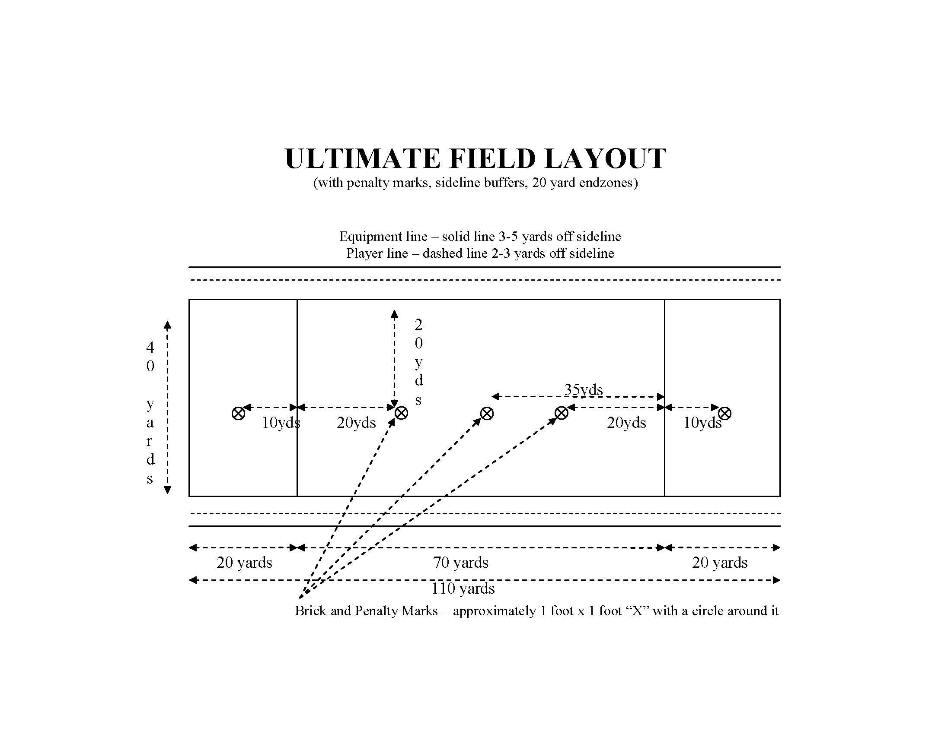
Appendix 2

Budget Expense Categories
Event Expenses
Facilities
Fields
Stadium
Rental Equipment
Utility carts
PA system
Porta johns
Radios
Tables/Chairs/Tent
Bleachers
Trash/Recycling
Water coolers/Ice chests
Storage truck
Generator
Labor
Medical
EMT
Trainers
Police/Security
Field Lining and Supplies
Shuttle Service
Staff Travel
Lodging
Food and Water
Water
Food
-Participant
-Staff
Supplies
Ice
Trash/Recycling Supplies
Discs
Other
Social Events
Facilities
Equipment
Food/Beverages
Supplies

